**Software Design Document**

1. Introduction-
   * + - The Purpose of this document is to outline the design and Implementation details for addition of Help Button with ‘?’ icon on the login page.
       - The Help Button will trigger a pop-up displaying company customer care number for different companies.
2. System Architecture-
   * + - The Help Button with ‘?’ icon will be part of user interface on login page.
       - Interaction involve server side (asp.net core MVC) components.
3. Components-
   * + - Controller:
         * HelpController : Action method for rendering the help view.
       - View:
         * Login.cshtml : Layout for login page with an integrated Help button and pop-up.
       - Javascript : Client side script handling Help Button click events and pop-up displays.
4. User Interface Design
   * + - Login Form

Integrate a help button on bottom right side on login page.

* + - * Pop-up

Display a pop-up when help button is clicked.

It include the list of countries with corresponding customer care numbers.

Allow users to close the pop-up.

1. Interaction Flow
   * + - User clicks the ‘?’ icon.
       - Client-side script triggers an AJAX call to the server.
       - The server-side HelpController responds with customer support information.
       - The pop-up is dynamically displayed with received information.
2. Data Flow diagram of Interaction flow

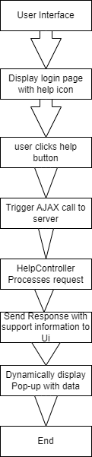

1. Data Design
   * + - The list of countries and corresponding customer care number will be retrieved from predefined dataset.
       - Client-side javascript makes an asynchronous call to the server for data.
2. Security Design
   * + - Ensure secure data transfer using https between the client and server.
       - Implement proper server side validation and error-handling.
3. Implementation Details
   * + - Use Asp.net core MVC to create helpController and views.
       - Leverage client-side javascript for handling button clicks and AJAX requests.
4. Testing strategy
   * + - Unit testing-Verify the functionality of the help button and pop-up.
       - Integration testing-Ensure proper integration with existing login page.
       - User Acceptance testing- Test with users to ensure the help button meet there needs.
5. Performance Considerations
   * + - Test the performance of the help button to open within 1 seconds on different devices and browsers.
6. Maintenance and Support
   * + - Include updates for any update to help button
7. Documentation
   * + - Provide documentation to developers to understand the implementation.
       - Include user documentation explaining how to use help button.